Notes for Secretary Report NAFAE AGM 26th April 2024
2 Camels
I am calling this ‘report’ something like ‘between the ‘straw that broke the camel’s back and the story of the weeping camel’.
This is my way of trying to think where we are between ‘bordering on despair’ and ‘never losing hope’.
The current landscape for art and design education seems to many of us perhaps to be caught in a bit of a seismic shift even since a number of us met in the conference at The School of Mosaic in north west London in 15th September 2023…”Revisiting the Fine Art Graduate”.
We may not have imagined then the extent to which Universities in particular across the sector would have to go into various forms of ‘restructure’ mode. This may or may not be variously impacting upon Art and Design but ‘straws breaking backs’ may be where there has had to be a significant overhaul of academic staffing, where Schools may be asked to re-align differently within, or combine with other Schools and overhaul courses, so as to reduce costs…
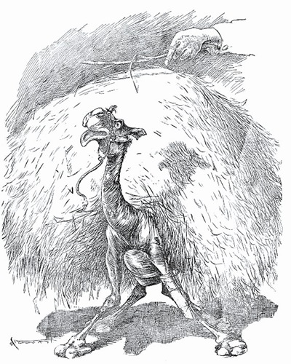

But………..now let me talk about the story of the ‘weeping camel’…a beautiful lyrical film about a Mongolian nomadic tribe in the Gobi desert…one of their camel’s gives birth to a calf , a rare white calf, that she then seems to reject…the nomad family and especially the young boy as I recall is doing all he can to get the mother to accept the calf and give it succour…first the tribe call in the ‘lama’-a Buddhist monk offering spiritual guidance …but...no matter how much chanting …it seems not to work…
But then later…a violin playing traveller appears…( a particular type of Mongolian violin called the morin khuur or ‘horsehead fiddle’)…the wonderful sounds of this violin fill the sky…the mother of the boy in the tribe starts to share in the rhythm and the tone of the violin’s sound…and…after a while…
The mother camel unbelievably starts to weep…and upon weeping turns to her calf and gives it succour…
See….art saves and finds life…art saves art…and gives meaning to work…so we must not give up…and we didn’t give up at the School of Mosaic.
That conference in a wonderful and distinctive local setting produced a conference that was global in its reach. Its ideas were practical, aspirational and inspirational. What struck me about that conference was the strong sense we gave to the variety of exciting and innovative and unconventional ways in which art answers to all the call for ‘employability’ but also called back to all that we had said about ways of thinking ‘community’ in Birmingham the year before …and it was about art and life in the call for us to remember Joe Woodhouse and Foundation Press and the plan for the event at Newcastle Contemporary Art next year…the conference was all about what art Gives…and does not ‘take away’…
This was also the introduction to and opportunity for some of us coming to together in the webinar/conversation about the politics of ‘alternative art education’ in support of Richard Hudson- Miles and Jackie Goodman’s book…what a great happening that was…who knew we would generate such thoughtful and provoking ideas.
Many of us may be thinking more and more about our links and togetherness with all forms of art education and furthering these to inform us ‘beyond’ the contexts of Higher Education…this I hope give us strength to face the coming challenges and NAFAE is very valuable indeed, especially I think, in terms of its openness and the welcome given to such a wide reaching community….
We may feel like weeping but we still nourish each other.
To be scholarly, I end with a quote from a book by Hannah Proctor*…’ it is possible to mourn and organise at once, and do both without compromise…
So yes, let’s keep organising around the positivity of art and its spaces and places for cultural sustainability and nourishment…

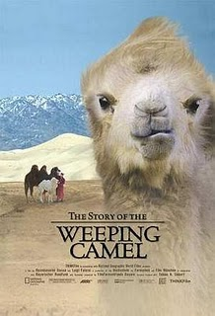

*Proctor H (2024) ‘Burnout-the emotional experience of political defeat’…London Verso Books 2024

Jenny Walden Secretary NAFAE

